Hashtag Trend Analysis Using Python and Dashboard Visualization

ABSTRACT
This project analyzes hashtag trends using a dataset containing posts, likes, and retweets. The data is processed using Python for cleaning, transformation, and exploratory data analysis. Big data concepts such as MapReduce and distributed processing are applied conceptually to handle large datasets efficiently. The processed data is then visualized using an interactive dashboard built with Google Charts. The dashboard provides insights into trending hashtags, engagement levels, and user interaction patterns.

INTRODUCTION
With the rapid growth of social media platforms, large volumes of data are generated every second. Hashtags help categorize and identify trending topics. Analyzing hashtag data enables better understanding of user engagement, content popularity, and social trends.
This project demonstrates how big data techniques and visualization tools can be combined to extract meaningful insights from hashtag datasets.

OBJECTIVES
- Analyze hashtag trends over time
- Measure engagement (Likes + Retweets)
- Identify top-performing hashtags
- Apply big data concepts like MapReduce
- Build an interactive dashboard for visualization

HOW DATA IS COLLECTED
Data collection is done using:
- CSV dataset (structured data format)
- Data simulates real-world social media data
Dataset Fields:
- Hashtag
- Date
- Posts
- Likes
- Retweets
👉 In this project:
- Data is loaded using Python (pandas.read_csv())
- File path:
C:\Users\Dell\OneDrive\Desktop\Bigdata\hashtag_trends.csv

PYTHON IMPLEMENTATION
Steps:
- Load dataset
- Convert Date column to datetime
- Sort data by date
- Create new column:
Engagement = Likes + Retweets
- Group data:
df.groupby("Hashtag")["Posts"].sum()

PYTHON CODE
import pandas as pd
import matplotlib.pyplot as plt
import seaborn as sns
df = pd.read_csv(r"C:\Users\Dell\OneDrive\Desktop\Bigdata\hashtag_trends.csv")
print(len(df))
# Convert date column
df['Date'] = pd.to_datetime(df['Date'])

# Sort data
df = df.sort_values('Date')
hashtag_counts = df.groupby("Hashtag")["Posts"].sum()
# Plot 1: Posts over time
plt.figure(figsize=(12, 6))
sns.lineplot(data=df, x="Date", y="Posts", hue="Hashtag", marker="o")
plt.title("Hashtag Trend Analysis (Posts Over Time)")
plt.xticks(rotation=45)
plt.tight_layout()
plt.show()

# Plot 2: Total posts per hashtag
plt.figure(figsize=(10, 5))
sns.barplot(data=df, x="Hashtag", y="Posts", estimator=sum)
plt.title("Total Posts per Hashtag")
plt.xticks(rotation=45)
plt.tight_layout()
plt.show()
# Plot 3: Engagement comparison
df['Engagement'] = df['Likes'] + df['Retweets']
plt.figure(figsize=(10, 5))
sns.boxplot(data=df, x="Hashtag", y="Engagement")
plt.title("Engagement Distribution by Hashtag")
plt.xticks(rotation=45)
plt.tight_layout()
plt.show()
# Plot pie chart
plt.figure(figsize=(8, 8))
plt.pie(
hashtag_counts,
labels=hashtag_counts.index,
autopct='%1.1f%%',
startangle=140
)
plt.title("Hashtag Distribution by Total Posts")
plt.axis('equal') # Equal aspect ratio for perfect circle
plt.show()
# Scatter plot
plt.figure(figsize=(10, 6))
sns.scatterplot(
data=df,
x="Posts",
y="Likes",
hue="Hashtag",
palette="Set2"
)
plt.title("Posts vs Likes (Hashtag Analysis)")
plt.xlabel("Number of Posts")
plt.ylabel("Number of Likes")
plt.legend(title="Hashtag")
plt.tight_layout()
plt.show()
OUTPUT:
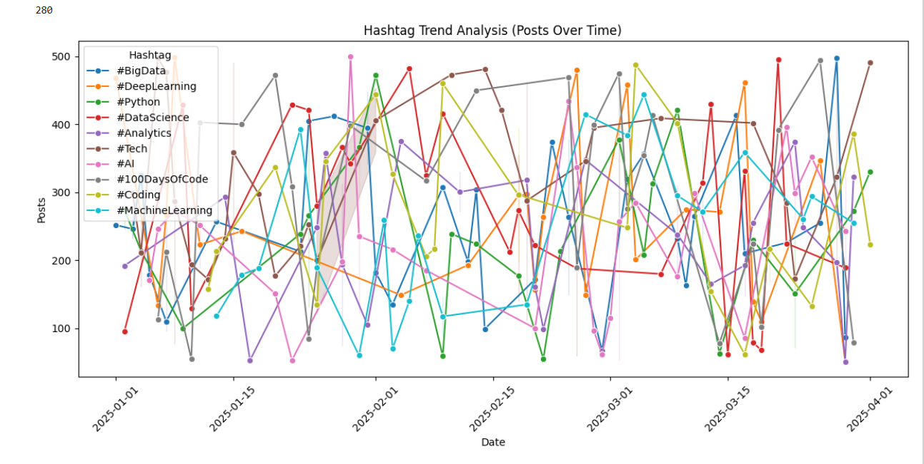
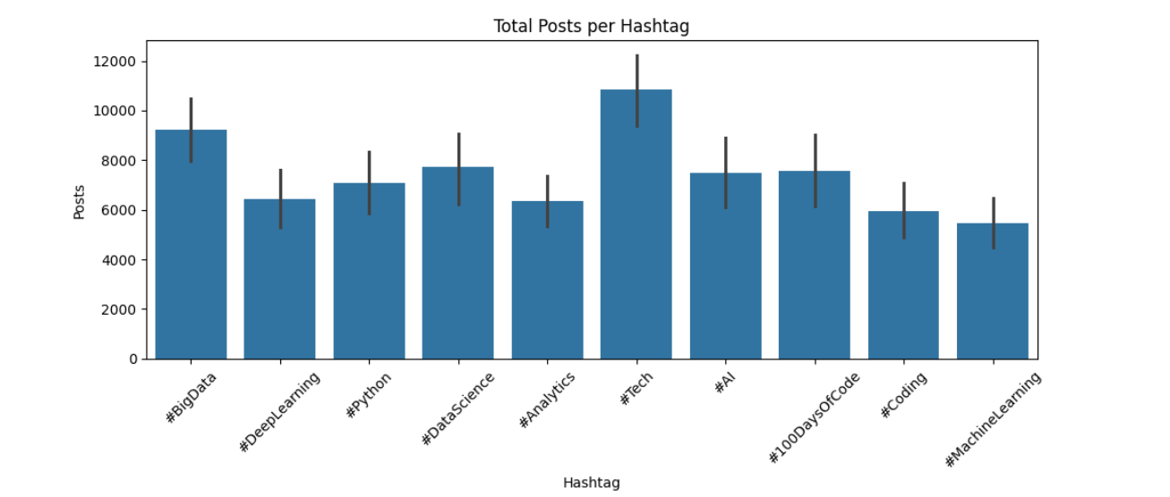
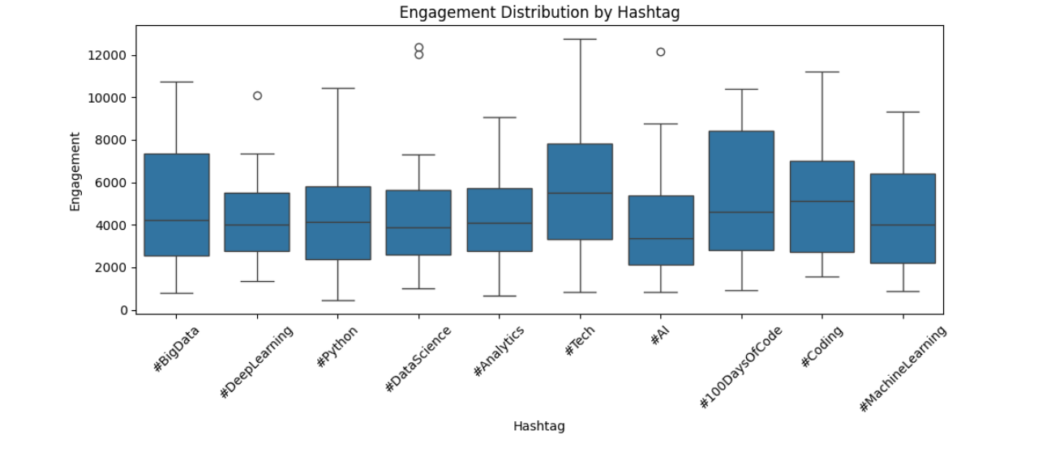
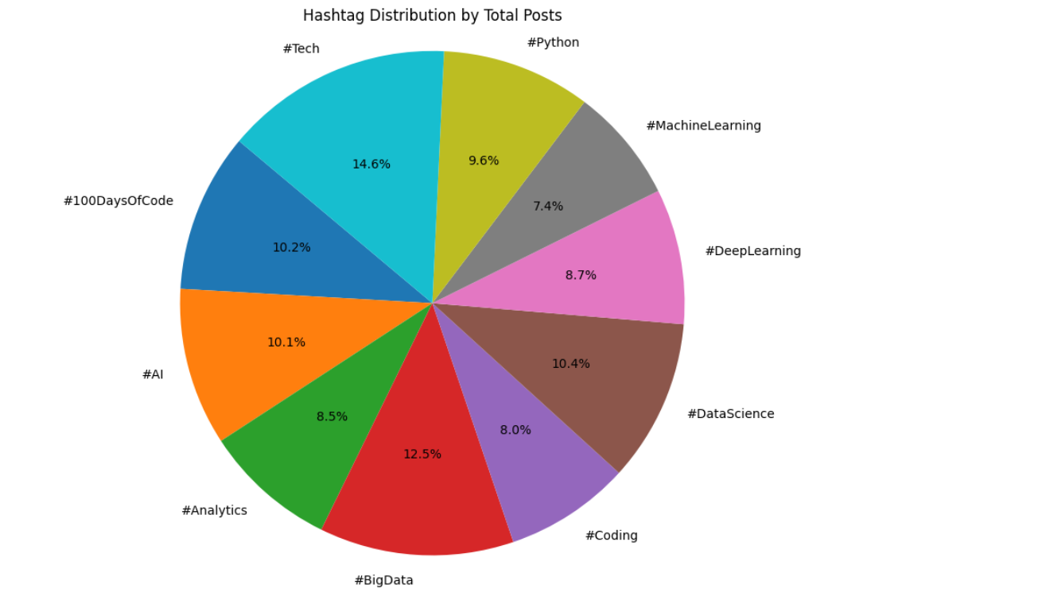
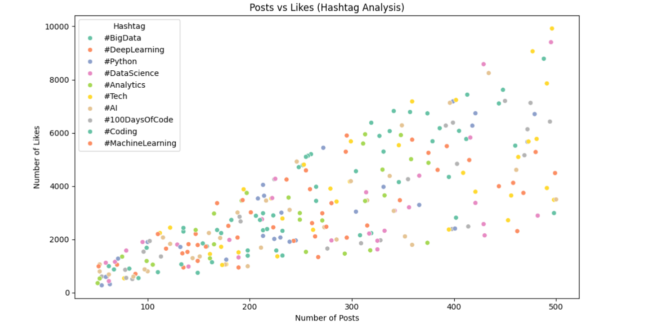

HOW MAPREDUCE CONCEPT IS USED
Conceptually using Hadoop:
🔹 Map Phase
- Data is split into smaller parts
- Each mapper processes records:
(#AI, 396)
(#Python, 421)
🔹 Reduce Phase
- Aggregates results:
#AI → Total Posts
#Python → Total Engagement
👉 In your Python code:
- groupby() acts like Reduce
- Data splitting acts like Map

PYTHON CODE
import pandas as pd
from collections import defaultdict
df = pd.read_csv(r"C:\Users\Dell\OneDrive\Desktop\Bigdata\hashtag_trends.csv")
print("Dataset Loaded:", df.shape)

# MAP PHASE
mapped_posts = []
for _, row in df.iterrows():
hashtag = row["Hashtag"]
posts = row["Posts"]
mapped_posts.append((hashtag, posts))
print("\nMapped Posts Sample:", mapped_posts[:5])

# REDUCE PHASE
reduced_posts = defaultdict(int)
for key, value in mapped_posts:
reduced_posts[key] += value
print("\n===== TOTAL POSTS PER HASHTAG =====")
for k, v in reduced_posts.items():
print(k, "->", v)
# Convert to DataFrame
posts_df = pd.DataFrame(list(reduced_posts.items()),
columns=["Hashtag", "Total_Posts"])
# MAP PHASE
mapped_engagement = []
for _, row in df.iterrows():
hashtag = row["Hashtag"]
engagement = row["Likes"] + row["Retweets"]
mapped_engagement.append((hashtag, engagement))
print("\nMapped Engagement Sample:", mapped_engagement[:5])
# REDUCE PHASE
reduced_engagement = defaultdict(int)
for key, value in mapped_engagement:
reduced_engagement[key] += value
print("\n===== ENGAGEMENT PER HASHTAG =====")
for k, v in reduced_engagement.items():
print(k, "->", v)
# Convert to DataFrame
engagement_df = pd.DataFrame(list(reduced_engagement.items()),
columns=["Hashtag", "Engagement"])
# MAP PHASE
mapped_trend = []
for _, row in df.iterrows():
key = (row["Date"], row["Hashtag"])
value = row["Posts"]
mapped_trend.append((key, value))
print("\nTrend Mapped Sample:", mapped_trend[:5])
# REDUCE PHASE
reduced_trend = defaultdict(int)
for key, value in mapped_trend:
reduced_trend[key] += value
print("\n===== DAILY TREND OUTPUT =====")
for k, v in list(reduced_trend.items())[:10]:
print(k, "->", v)
# Convert to DataFrame
trend_df = pd.DataFrame(
[(k[0], k[1], v) for k, v in reduced_trend.items()],
columns=["Date", "Hashtag", "Total_Posts"]
)
print("\n\n===== FINAL TABLES READY =====")
print("\nPosts per Hashtag:")
print(posts_df)
print("\nEngagement per Hashtag:")
print(engagement_df)
print("\nTrend Data Sample:")
print(trend_df.head())
OUTPUT:
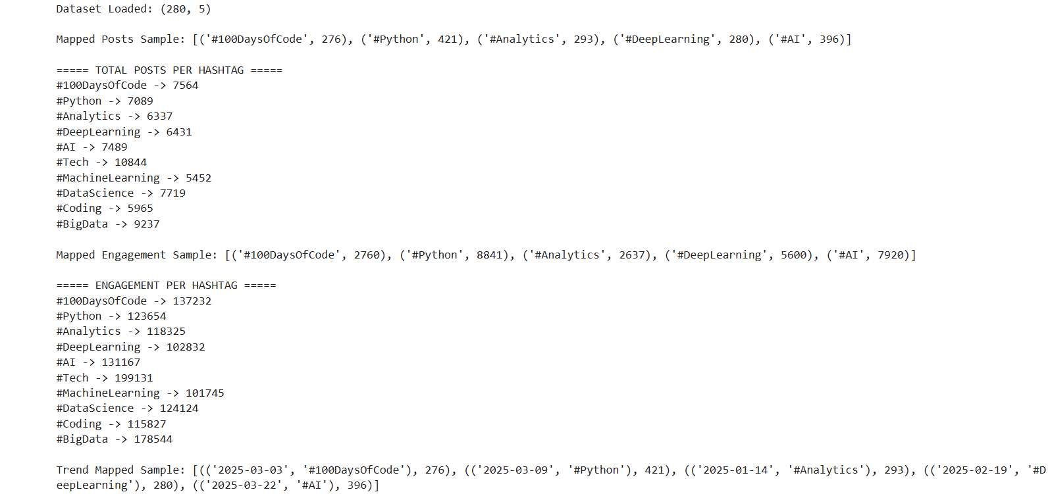
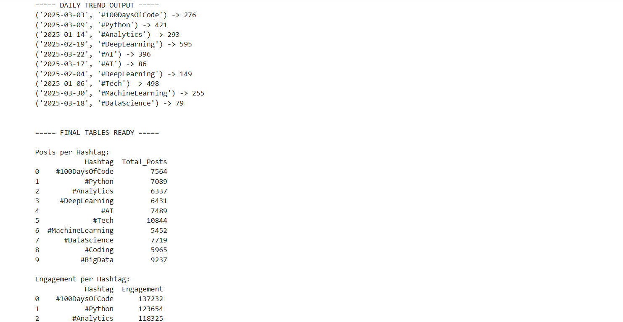
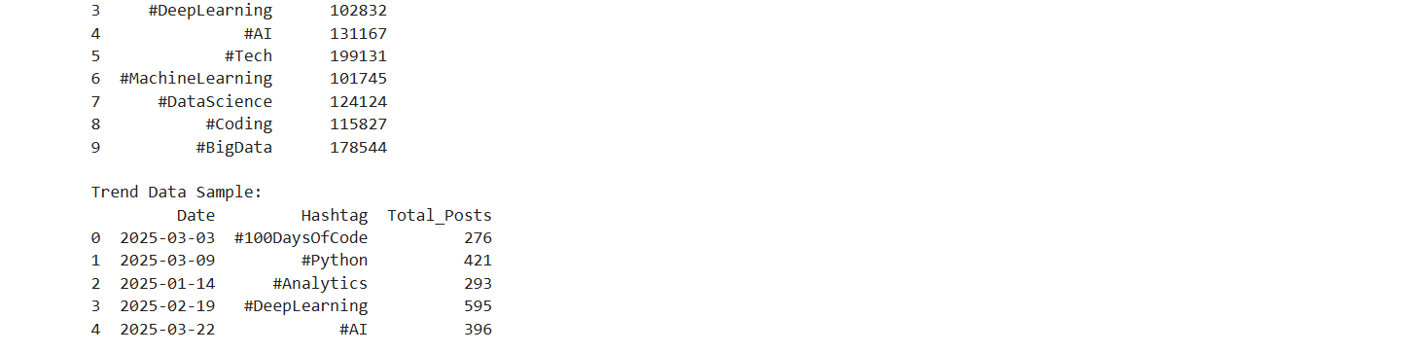

HOW DATA IS DISTRIBUTED
Using Hadoop Distributed File System (HDFS):
- Data is divided into blocks
- Stored across multiple nodes
- Processed in parallel
Advantages:
- High performance
- Scalability
- Fault tolerance

USE OF BIG DATA TOOLS
🔹 Apache Hive
- Used for SQL-like queries

HASHTAG TREND ANALYSIS USING HIVE
🧩 STEP 1: Setup Hadoop + Hive Environment
Before anything:
Install / ensure:
- Hadoop (HDFS running)
- Hive installed
- Beeline / Hive CLI working
Check:
hdfs dfs -ls /
hive --version

📁 STEP 2: Create Directory in HDFS
Upload dataset to HDFS:
hdfs dfs -mkdir -p /user/hive/hashtag_project
Upload CSV:
hdfs dfs -put hashtag_trends.csv /user/hive/hashtag_project/

🗄 STEP 3: Create Hive Database
CREATE DATABASE hashtag_db;
USE hashtag_db;

📊 STEP 4: Create Hive Table
External table (recommended)
CREATE EXTERNAL TABLE hashtag_trends (
Date STRING,
Hashtag STRING,
Posts INT,
Likes INT,
Retweets INT
)
ROW FORMAT DELIMITED
FIELDS TERMINATED BY ','
STORED AS TEXTFILE
LOCATION '/user/hive/hashtag_project/';

🧹 STEP 5: Clean & Format Date Column
Hive doesn’t automatically convert datetime, so:
SELECT
CAST(Date AS DATE) AS clean_date,
Hashtag,
Posts,
Likes,
Retweets
FROM hashtag_trends;

📈 STEP 6: Hashtag Trend Over Time (Main Analysis)
👉 This replaces your Python lineplot
SELECT
Date,
Hashtag,
SUM(Posts) AS total_posts
FROM hashtag_trends
GROUP BY Date, Hashtag
ORDER BY Date;
✔ Use this output in Python/Power BI for line chart

📊 STEP 7: Total Posts per Hashtag (Bar Chart Data)
SELECT
Hashtag,
SUM(Posts) AS total_posts
FROM hashtag_trends
GROUP BY Hashtag
ORDER BY total_posts DESC;

💡 STEP 8: Engagement Calculation
Add engagement metric:
SELECT
Hashtag,
Likes + Retweets AS engagement
FROM hashtag_trends;

📦 STEP 9: Engagement by Hashtag (Boxplot Data)
SELECT
Hashtag,
Likes + Retweets AS engagement
FROM hashtag_trends;
✔ Export this for visualization tools

🥧 STEP 10: Hashtag Distribution (Pie Chart Data)
SELECT
Hashtag,
SUM(Posts) AS total_posts
FROM hashtag_trends
GROUP BY Hashtag;

📊 STEP 11: Posts vs Likes (Scatter Data)
SELECT
Hashtag,
Posts,
Likes
FROM hashtag_trends;

📤 STEP 12: Export Hive Results (Very Important for Project)
To save output:
INSERT OVERWRITE DIRECTORY '/user/hive/output/hashtag_results'
ROW FORMAT DELIMITED
FIELDS TERMINATED BY ','
SELECT Hashtag, SUM(Posts)
FROM hashtag_trends
GROUP BY Hashtag;

HOW VISUALIZATION IS DONE
🔹 Python Visualization
Using Seaborn & Matplotlib:
- Line Plot → Trends over time
- Bar Plot → Total posts
- Pie Chart → Hashtag distribution
- Scatter Plot → Posts vs Likes

🔹 Dashboard Visualization
Using Google Charts:
Charts Used:
- 🥧 Pie Chart → Hashtag distribution
- 📊 Column Chart → Posts per hashtag
- 🔵 Scatter Plot → Posts vs Likes
- 📈 Line Chart → Trends over time
Features:
- Interactive dashboard
- Filters (Posts range filter)
- Multiple visual insights
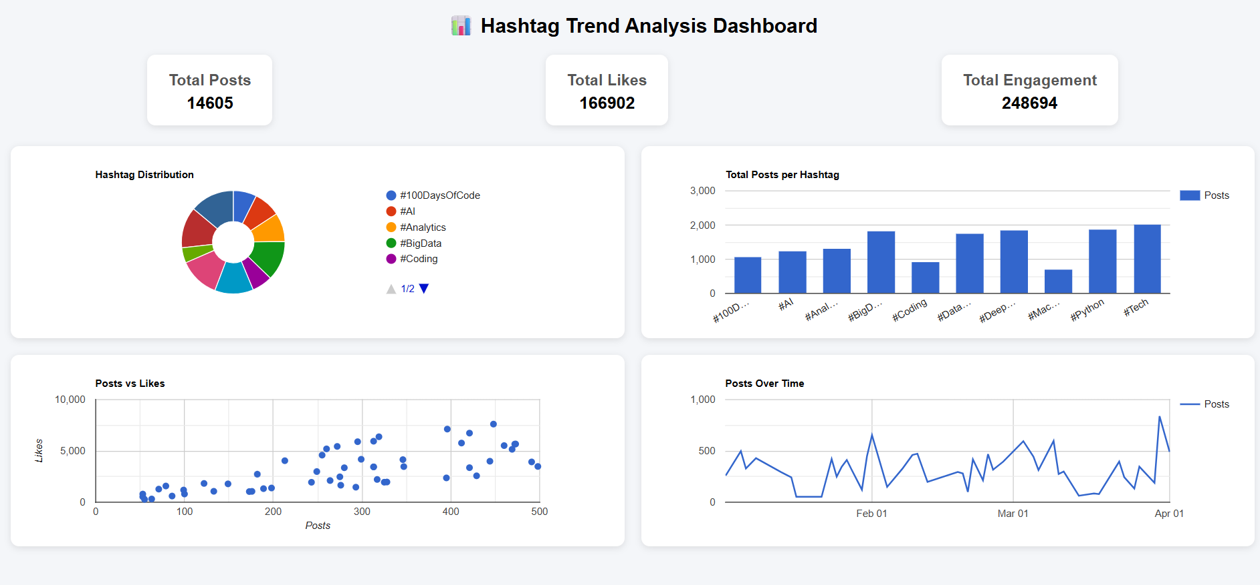

RESULTS
- Identified trending hashtags
- Analyzed engagement patterns
- Compared performance across hashtags
- Built a user-friendly dashboard

CONCLUSION
This project demonstrates how big data techniques and visualization tools can be used to analyse hashtag trends effectively. By combining Python-based data processing with an interactive dashboard, meaningful insights were derived from the dataset. The project highlights the importance of big data in real-world analytics.

